**DIGITAL MARKETING ASSINGNMENT**



BE-Computer Science and Engineering

Vivekanandha College of Technology for Women

Namakkal-637205

NM id: 1222E69635B68E8B8BB447206D38112C

**Submitted by:**

KEERTHIGA.N au613020104039

* **BRAND NAME:**

Foodblish

* **LOGO:**



**1.Create a blog or website using Blogspot and Wordpress.**

Blogspot: <https://keerthiga4946.blogspot.com/2023/10/foodblish.html>

**2.Create a New Facebook Business Page and Post one social Media poster.**

Business page link: <https://www.facebook.com/profile.php?id=61551887559008&mibextid=ZbWKwL>

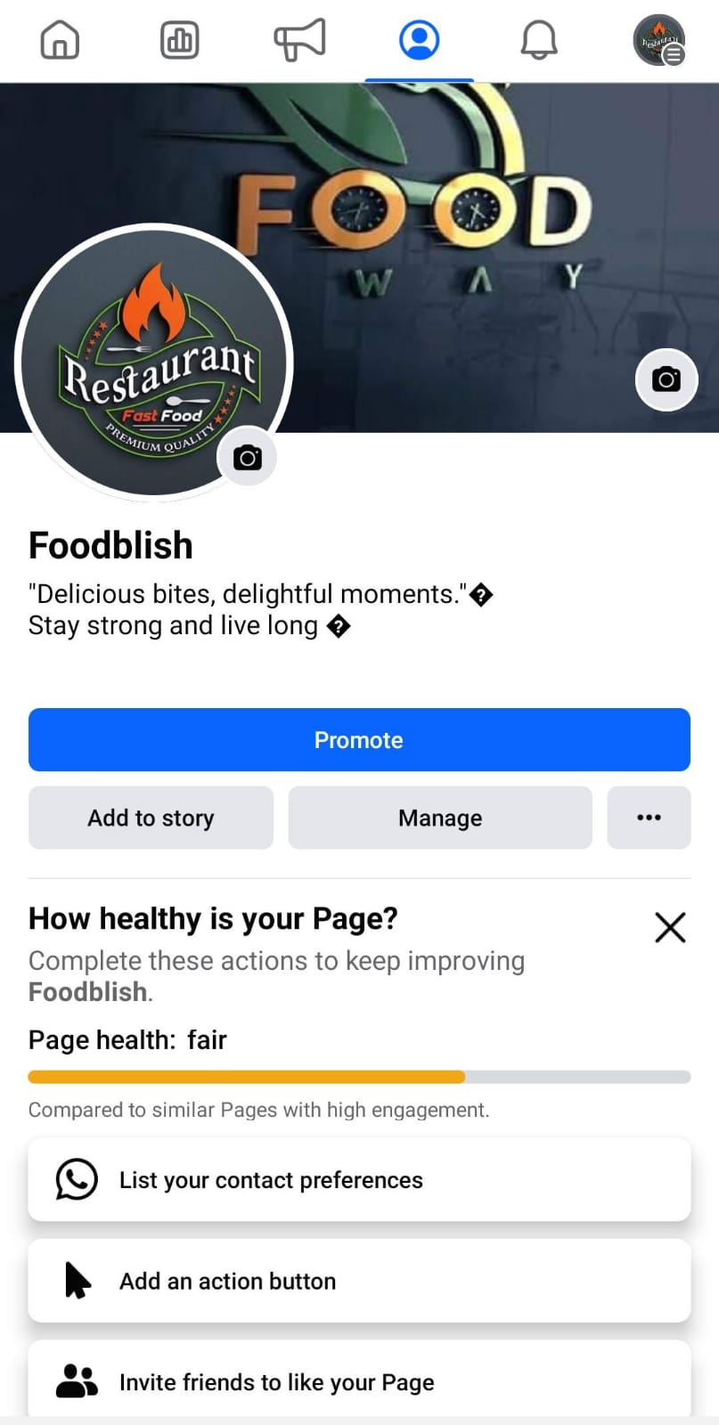

**3.Socia media advertisement poster using canva**.

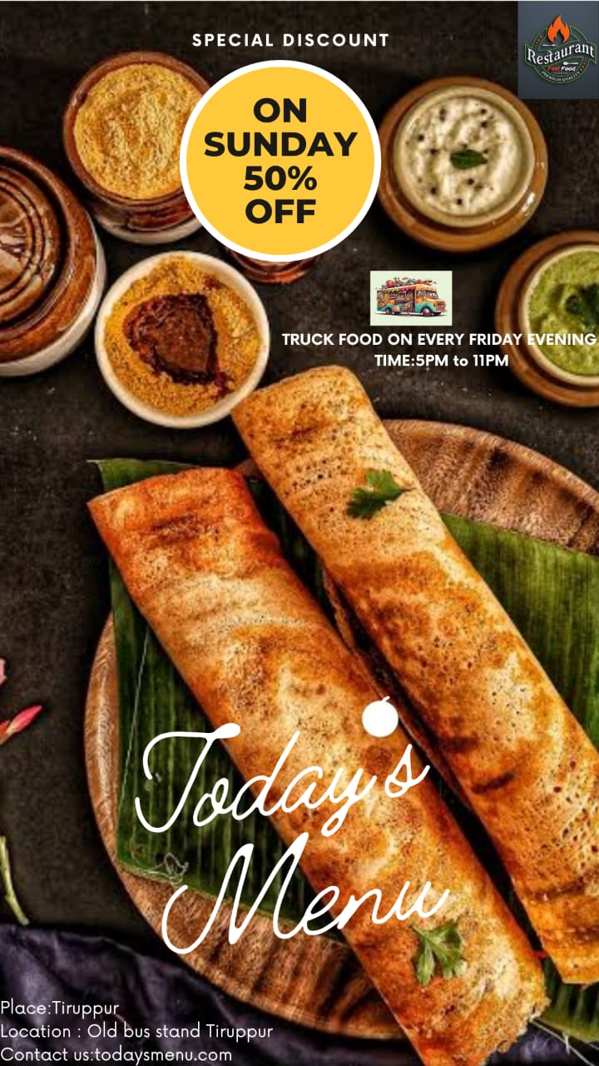

**4.E-mail newsletter using Mail chimp or canva**

